**Section** 301 (TBD), Spring Quarter

**Time:** Tuesday: 6:00pm – 9:00pm

**Location:** DePaul Lewis Center 1403

Click here to enter text.

**Instructors:**

Dr. Ron Nahser [Rnahser@depaul.edu](mailto:Rnahser@depaul.edu)

Dr. Scott Kelley [Skelley@depaul.edu](mailto:Skelley@depaul.edu)

Click here to enter text.

# purpose of the Course

GSB 595 Developing Sustainable Strategies shares the same purpose as the United Nation’s Principles for Responsible Management Education (PRME) to “develop the capabilities of students to be future generators of sustainable value for business and society at large and to work for an inclusive and sustainable global economy” (Principle 1). As such, it seeks to integrate the concept of *strategy development* into the larger ecological economic context of serving market/society needs in a finite world.  The goal of strategy in organizations has traditionally been defined as one of value maximization, from the shareholder perspective exclusively. To generate sustainable value for business and society, strategy must guide organizations in competitively defining and meeting market/society’s needs.

# Business Model, Business Plan and presentation

*Business Model*

A business model/platform describes the rationale of how an organization creates, delivers, and captures value by serving market/society needs in a competitive environment.

Since this Course recognizes the competitive nature of capitalism - creative destruction *(Schumpeter)* - we will also be putting emphasis on competitive analysis. The end result Is the development of a business plan to intervene in a system – to change buying behavior. The plan is designed for presentation to an audience that can provide resources – financial, time, support, etc. - for implementation.

The first step - classes 1-7 - will be to engage in In researching the nine elements In the Business Model Canvas:



*Business Plan*

In classes 8-10 this information from the Model will be put it into the more traditional Business Plan format:

* Company Overview
* Competitive Analysis
* Market Analysis
* Strategy
* Products/Services
* Marketing & Sales
* Management & Personnel
* Operations
* Financial Projections
* Appendices

*Presentation*

The final result will be an “Elevator pitch” of the Plan.

*Values.* An inclusive and sustainable global economy demands a clear commitment to “the values of global social responsibility as portrayed in international initiatives such as the United Nations Sustainable Development Goals and the UN Global Compact” (PRME Principle 2). The Ten Principles of the UN Global Compact will serve not only as a set of ethical standards to be recognized but, more importantly, as a morally imaginative lens through which students will identify, define, and respond to a particular set of market/society needs in a way that builds a sustainable global economy. That is, the ten principles of the UN Global Compact concerning human rights, labour, environment, and anti-corruption will be positioned in terms of *sustainable strategy development* and not merely moral obligation.

*Method*. Each student will be responsible for generating their own research - bibliography - and crafting the messages – blogs - based on their research.

With the primary aim of developing strategy that creates sustainable value for business and society in a global economy, GSB 595 will employ an educational framework – Pragmatic Inquiry® – that enables “effective learning experiences for responsible leadership” (PRME Principle 3). Responsible leadership able to develop sustainable strategy demands that students locate the broader aims and values of the UN Global Compact in an ongoing *arc of inquiry* that emerges from and responds to a particular Challenge / question (**Cq**). Because responsible leadership must operate on *all* levels of human consciousness, not merely the level of planning or tactics - Pragmatic Inquiry asks students to begin attentively, explore openly, interpret imaginatively, decide responsibly, and act courageously. Theory, practice, and self-knowledge must inform each other if students are to become the kind of responsible leaders able to develop sustainable strategies – the business case - and sell them.

# Learning Goals and outcomes

To generate sustainable value for business and society, students must engage in new ways of thinking and new patterns of inquiry. This goal requires a new pedagogy - one that asks students to be conscious of their own assumptions, their own patterns of knowing. The new pedagogy must also ask students to make connections between data and disciplines that were previously viewed as unrelated or disconnected. Rather than predetermining a clear development of thought in a particular set of readings that define a discipline, this course demands that students find emerging connections in a broad survey of literature and ideas. While the content of the course is appropriately broad-ranging and eclectic, the particular learning *goals* of DePaul University are shaped by the learning *method* of Pragmatic Inquiry:

***Goal 1: Mastery of Content***. *Outcome:* Students will demonstrate specialized knowledge and skills sufficient for developing a strategy that meets a particular societal /market need in way that builds a sustainable global economy

***Goal 2***: ***Intellectual and Creative Skills***. *Outcome:* Students will demonstrate the ability to think critically and imaginatively by accessing, analyzing, and evaluating information from multiple sources to identify underlying assumptions, by using existing knowledge to generate and synthesize ideas in original ways, and by communicating clearly in speech and writing

***Goal 3: Personal and Social Responsibility***. *Outcome:* Students will demonstrate the ability to identify and articulate their own assumptions, beliefs, and values – as well as others – about the meaning(s) of a sustainable economy, to articulate what it means to live with personal integrity, to evaluate ethical issues from multiple considerations and to chart a responsible course of action that benefits various communities.

***Goal 4: Intercultural and Global Understanding***. *Outcome:* Students will demonstrate knowledge of and respect for perspectives that diverge from their own, and sufficient knowledge to become a prudent steward of global resources in a finite ecology.

***Goal 5: Integration of Learning***. *Outcome:* Students will demonstrate the ability to relate their learning, making connections among a broad range of ideas and experiences, in order to design and develop a sustainable strategy for meeting a particular societal / market need.

***Goal 6: Preparation for Career and Beyond.*** *Outcome:* Students will demonstrate the ability to identify a society need and develop and present a business plan for a product or service that will sustainably meet that need. This identifies and leads to the next step in the student’s career path.

# Assessment

Baseline Reflection (pass/fail) 10%

Inquiry Blogs – comments on various elements in the Business Model

Including Bibliography - 30%

Interpret Exercises (pass/fail) 10%

Business Plan 30%

Elevator Pitch 10%

Final Reflection Essay (pass/fail) 10%

**Total 100%**

Grading Scale

A 94 – 100

A- 90 – 93.9

B+ 87 – 89.9

B 84 – 86.9

B- 80 – 83.9

C+ 77 – 79.9

C 74 – 76.9

C- 70 – 73.9

D 64 – 69.9

F Below 64

Note: ALL assignments will be submitted through the Pragmatic Inquiry Digication ePortfolio and graded on a 10 point scale.

***Baseline Reflection***. Baseline Reflection responses should address all FIVE of the questions in the Pragmatic Inquiry Digication ePortfolio. Assessment is pass/fail.

***Inquiry Blogs****.* Critical inquiry and critical self-reflection are ongoing activities essential for developing sustainable strategies. As such, students are required to write THREE separate inquiry blogs, no shorter than 350 words: Market – Demand (classes 2-3) Organization – Supply (classes 4-5) Society and Environment (class 6) ,

Each Inquiry blog should have its own list of references and citations using the author-date format. Inquiry blogs should demonstrate that the student is engaging course content critically, is continuing to identify new insights and new questions related to their Challenge/question, and is able to summarize, synthesize and apply concepts from multiple perspectives and multiple sources.

The inquiry blogs will be assessed according to the following questions: Does the inquiry blog, in its entirety, demonstrate (a) the ability to synthesize and integrate multiple perspectives from multiple sources, and (b) the ability to make meaningful connections to the student’s Challenge/question.

***Interpret Assignments****.* Developing sustainable strategy is not just a matter of gathering data, but also on *interpreting* data from multiple sources. As such, students are required to complete EACH of the interpret assignments (External Conversation, Internal Conversation, Habits, and Maps) in the appropriate section under the “Interpret Imaginatively” tab of the Pragmatic Inquiry Digication ePortfolio. Assessment is pass/fail.

***Industry, Organization, Business Strategy Plan***. Each student is expected to prepare a conceptual plan that justifies a particular sustainable strategy. Students must address all of the questions identified in the “Business Model” section of the “Decide Responsibly” tab of the Pragmatic Inquiry Digication ePortfolio. The Business Plan is the comprehensive summary of the student’s work over the entire quarter and will be assessed according to the following questions:

Does the Business Plan:

* present an issue that has a clear need, a defined scope, a unique challenge, an imaginative response?
* demonstrate substantive research and critical inquiry that includes relevant data and multiple stakeholder perspective?
* have substantive content, clear logic, and a competitive financial strategy?
* have a reasonable action plan - milestones, contingencies and realistic timeframe?
* use a style, rhetoric, mode of presentation that is motivating, that compels action?

***Elevator Pitch***. Having a good idea and a solid business plan is a great start, but it is insufficient if key ideas are not communicated effectively. Students will present a 5-7 minute “elevator pitch” that effectively communicates the Business Plan. (This presentation can be either a poster board or a PowerPoint presentation). Since 5-7 minutes of speaking time translates into 500-800 words (approximately), students will post a brief summary of their business plan (no more than 800 words) in the “Elevator Pitch” section of the “Act Courageously” tab of the Pragmatic Inquiry Digication ePortfolio before class ten. The Elevator Pitch will be assessed on the ability to clearly present the outlines of the Business Plan, as follows:

Does the Elevator Pitch

* present an issue that has a clear need, a defined scope, a unique challenge, an imaginative respond?
* communicate key data points in a clear summary way?
* include a top-line financial strategy?
* have a call to action?
* use a style, rhetoric, and tone that is motivating?

***Final Reflection Essay***. To better understand the arc of inquiry and the iterative nature of Pragmatic Inquiry, students will post a final reflection essay in the “Final Reflection Essay” section in the “Act Courageously” tab of the Pragmatic Inquiry Digication ePortfolio. Assessment is pass/fail.

# Required Texts

Corporantes, Pathfinder Lab Journal (available at B&N Bookstore in the Loop)

Readings posted on ARES

Optional: F. Byron (Ron) Nahser,

[Learning to Read the Signs: Reclaiming Pragmatism for the Practice of Sustainable Management](https://www.amazon.com/Learning-Principles-Responsible-Management-Education/dp/1906093792/ref=sr_1_3?s=books&ie=UTF8&qid=1549411004&sr=1-3&keywords=learning+to+read+the+signs)

# About the Instructors

Ron Nahser, PhD, is the Director, Urban Sustainable Management Programs and Senior Fellow, Institute for Nature and Culture at DePaul University, and the Provost Emeritus of Presidio School of Management. He is professor of Ecological Economics and Pragmatic Philosophy at Zhejiang University Center for Confucian Entrepreneurship and Cultural Identity in Hangzhou, China. He lectures and consults with business and academic audiences in the U.S. and internationally on business values, vision, marketing strategy, branding and social responsibility. Nahser has an MBA from Northwestern’s Kellogg School of Management, an MA degree in Religious Studies from Loyola/Mundelein College and the PhD in American Pragmatic Philosophy from DePaul University.

# Course Schedule

**Tuesday, March 28th *Class 1 Introduction***

**Class Activity**

Introduction to Course and Instructors

Part 1: Creation of Pragmatic Inquiry Digication ePortfolio

Part 2: Overview of Pragmatic Inquiry

Part 3: Baseline Reflection

Part 4: Introduction of Business Model Generation: The “Business Canvas.”

Part 4: Preview of and preparation for Class 2 Explore Markets and Organizations

Assignments due this week:

* SUBMIT the Baseline Reflection under the “Begin Attentively” tab of the Pragmatic Inquiry Digication ePortfolio **by 11:59pm on Monday, April 3rd**  (pass/fail – ALL questions must be addressed in order to pass)
* Read Pathfinder pp 1-38 before next class
* Read Schumpeter “Creative Destruction” Summary in ARES

_________________________________________________________________________________

**Tuesday, April 4th *Class 2 Explore Markets***

**Class Activity**

Introduction: Review of baseline reflections with focus on Challenge/question **Cq (Creative Destruction)**

Part 1: Explanation and Discussion of Markets (Customer Segments)

Key Questions: How big is the market?  What are the market trends?  What is the market potential? How many market segments - customer characteristics and buying profiles? Which segment will you target?  Who are your potential customers? What do they need?

Competition: Who are your market competitors? Who are their target segments?

Revenue: what is your projected revenue - your pricing strategy? What are your competitors’ revenue and pricing strategy?

Class Readings

Marketing Management, Kotler/Keller Chapter 2: “Developing Marketing Strategies and Plans”

The Strategy Process, Mintzberg, et. al. Chapter 5.1 “Crafting Strategies”

_________________________________________________________________________________

**Tuesday, April 11th *Class 3 Explore Macromarket (channels)***

**Class Activity**

Part 2: Methods of Customer Relationships and Channels of Distribution

Key Questions:

Channels: How is the market being served now –how many different channels – wholesalers, distributors, retailers? How is technology impacting channels? What channels are you using? What channels are your competitors using?

Communication: What methods/media of communication are being used to customer relationships? What methods/media are your competitors using?

Revenue: How do your distribution and customer relationship strategy impact your revenue stream?

Assignments due this week:

* PUBLISH a draft of the Explore Market and Explore Customer Relationship and Channels blog (10 points) by **11:59pm Sunday, April 16th**

**Class Readings:**

Marketing Management, Keller/Kotler, Chapter 4: “Conducting Marketing Research”

The Strategy Process, Mintzberg, et.al. Chap. 1.1 “The Five 5Ps of Strategy”

_________________________________________________________________________________

**Tuesday, April 18th *Class 4 Explore Organization – Yours.***

**NOTE: Class tonight will be divided into two parts and will be held in the** [**McGowan South Atrium**](http://www.depaul.edu/campus-maps/buildings/Pages/mcgowan-south.aspx) **(1110 W. Belden Avenue Chicago, IL 60614)**

**Part 1: Students will present posters at the Social Impact Fair for Graduates & Professionals from 5:30-7:00pm**

Please submit your abstract on the website: [tinyurl.com/socialimpactfair2017](http://tinyurl.com/socialimpactfair2017)

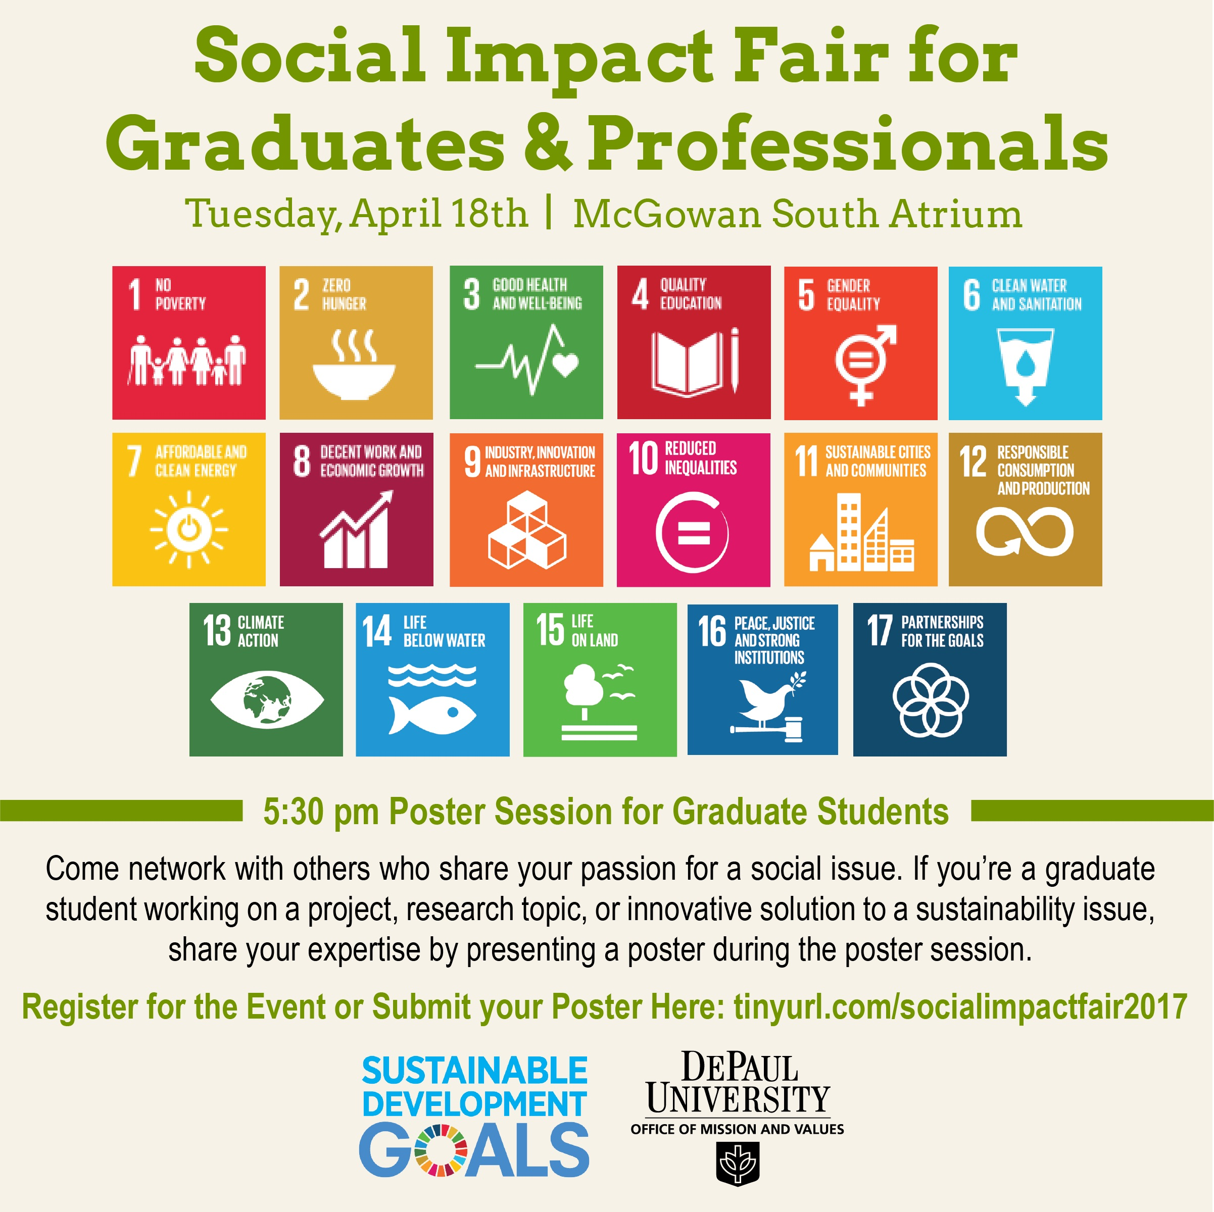

**Part 2: The second part of class will be a normal class immediately following the social impact fair.**

Explanation and Discussion of Organizations

Part 1: Your Organization

Key Questions: What is your organization’s mission (vision, goals, purpose and values)? What are your organization’s competencies and strategies?  What are key activities, resources and partnerships? What are the external barriers to entry?  What is your sustainable competitive advantage?

What is your expense structure?

**Class Reading**

The Strategy Process, Mintzberg, et.al. Chap. 2.4, “The Leader’s New Work: Building Learning Organizations.”

The Strategy Process, Mintzberg, et.al. Chap 5.2” Strategy as Strategic Decision Making”

_________________________________________________________________________________

**Tuesday, April 25st *Class 5 Explore Organizations - Competition***

**Class Activity**

Explanation and Discussion of Organizations - Competition

* Part 2 Competition:
* Key questions: What are your competitors’ missions and values? What are your competitors’ competencies and strategies? What are their strengths and weaknesses?  Who is their market? Who might enter the market when you are successful?
* What are your competitors’ expense structures?

Assignments due this week:

* SUBMIT the Organization Inquiry Blogs Digication ePortfolio **by 11:59pm on Sunday, April 30** (10 points)
* Read Pathfinder pp 41-44 before class on Tuesday, May 2nd

**Class Reading**

The Strategy Process, Mintzberg, et.al. Chap. 4.1, “ How Competitive Forces Shape Strategy”

The Strategy Process, Mintzberg, et.al. Chap. 8.3 “The Design of New Organizational Forms.

_________________________________________________________________________________

**Tuesday, May 2nd *Class 6 Explore - Society and Environment***

Professor Scott Kelley

**Class Activity**

Introduction: Review of Macromarketing

Part 1: Explanation and Discussion of Society

Key Questions: How do you define your larger society/community?  What are the broader social/cultural/political contexts and trends?  What is the regulatory/legal environment?  What NGO's are active in the community?

Part 2: Explanation and Discussion of Environment

Key Questions: What eco-system are you a part of?  What are the trends/threats/opportunities? What are the resources - stocks and flows - for your project?

Assignments due this week:

* PUBLISH a draft of the Explore Society and Environment blogs by **11:59pm Sunday, May 7th**

**Class Reading**

PathFinder “Explore – Society and Environment” pp. 41-44.

Pope Francis, *Laudato Si’*

Tu Weiming “Global Significance of Local Knowledge”,

Tu Weiming “The Ecological Turn in New Confucian Humanism:Implications for China and the World”

_________________________________________________________________________________

**Tuesday, May 9th *Class 7 Interpret Imaginatively***

**Class Activity**

**NOTE:** This class is Interpret exercises. Rest your right brain beforehand.

Part 1: Conversations

Key Questions: What is the Stakeholder systems view of your project?  What are the webs/systems of conversations among the Stakeholders?  Where are the points of leverage?  What are the possibilities for partnerships? What are the manufacturing supply chains and the market distribution systems?

Who have you talked with? What did they say? Who else do you need to talk with?

Part 2: Habits – See PathFinder

Part 3: Maps and Images – see PathFinder

Assignments due this week:

* PUBLISH Interpret Sections in Digication ePortfolio **by 11:59pm on Sunday, May 14th**  (pass/fail – ALL sections must be included in order to pass)

**Class Reading**

The Strategy Process, Chap. 2.2 “Artists, Craftsmen. And Technocrats.”

PathFinder Lab Journal - “Interpret” pp 45-60

Scharmer, Otto, [www.presencing.org](http://www.presencing.org) video and reading.

_________________________________________________________________________________

**Tuesday, May 16th *Class 8 Decide and Act - Implement – the business plan***

**Class Activity**

Introduction: Review of Interpret Imaginatively – bring all your work and PathFinders to class.

Part 1: Business Plan Discussion

Key Questions: What is the answer to your **Cq**? What is the market potential?  What is your pricing strategy vs. competition? Financial projections: pro forma income statement and balance sheet.  Cash flow projections?  Best and worst case scenarios? Sources and structure of financing? Market potential. Revenue, Expenses, Cash flow.  Run the numbers.

Part 2: Implement Discussion

Key Questions: How are you going to structure the organization? What are the key managerial roles?  Compensation and ownership structures?   What is/will be the culture – vision and values? What will be the governance? What will be success?  How will you measure it?  Milestones and key results indicators?  What are the internal  barriers?

Part 3: Instructions for business plan canvas financial plan

Key Exploration Questions: What is the market potential?  What is your pricing strategy vs. competition? Financial projections: pro forma income statement and balance sheet.  Cash flow projections?  Best and worst case scenarios? Sources and structure of financing? Market potential. Revenue, Expenses, Cash flow.  Run the numbers.

**Class Reading**

PathFinder, “Decide and Act” – pp. 61-69.

The Strategy Process, Chap. 7.2 “Strategy as Cognition.”

_________________________________________________________________________________

**Tuesday, May 25th *Class 9 Act -* *the presentation* *and communication strategies***

**Class Activity**

Introduction: review of business plan outline

Part 1: Communicate Discussion

Key Questions: What is your Unique Selling Proposition vs. competition?  What is the brand positioning and image?  What is the message? Who are the targets for your presentation?  What are the media to be used?  What is the role of social media?

**Class Reading**

The Strategy Process, Chap. 12.3. “The New Manifesto for Management.”

**Tuesday, June1 st *Class 10 Project Workshop Meeting***

_________________________________________________________________________________

Assignments due this week:

* PUBLISH the business plan **by 11:59pm on Sunday, June 4th**
* PUBLISH the presentation slides **by 11:59pm on Sunday, June 4th**

**Class Reading**

Livingston, J. Sterling, “The Myth of the Well-Educated Manager.”

**Tuesday, June 6th *Final Class Presentations*** _________________________________________________________________________________

**Class Activity -** Presentations

**Saturday June 9th *Final Essay*** _________________________________________________________________________________

Assignments due this week:

* PUBLISH the final reflection essay **by 11:59pm on Saturday, June 108h**